

**HEED Project**

**D4D Monitoring Demo instructions**

Created by Tomasz Prabucki on 21/08/18

More details at: [heed-refuge.coventry.ac.uk](http://heed-refugee.coventry.ac.uk/)

1. **List of requisites to transport:**

|  |  |
| --- | --- |
| 3 | S**olar Lantern prototype** – 1x GSM only, 1x SD only, 1x GSM+SD |
| 3 | **SUM prototype** – 1x GSM only, 1x SD only, 1x GSM+SD |
| 2 | **Streetlight prototype** - Raspberry Pi |
| 1 | BlueSolar Charge controller MPPT 75 15 |
| 1 | Victron Energy Battery Shunt |
| 2 | HDMI cables |
| 2 | VE.Direct to USB Victron Energy cable |
| 1 | Victron Energy BMV-700 Battery Monitor |
| 1 | HDMI to VGA active adapter |
| 3 | 3.7V 800mAh li-ion batteries |
| 1 | Raspberry Pi USB charger |
| 1 | Micro USB cable |
| 1 | USB extension cable |
| 1 | LED Floodlight |
| 1 | USD SD card reader |
| 1 | [iPazzPort Wireless Mini Handheld Keyboard with Touchpad](https://www.amazon.co.uk/gp/r.html?C=38VLIQ1P7ES9H&K=3FXKW4WI9QVOI&M=urn:rtn:msg:201808202021501194f6f504d64235814f43dc6db0p0eu&R=2NRETX0KIDPXI&T=C&U=https%3A%2F%2Fwww.amazon.co.uk%2Fdp%2FB00U6V0D5A%2Fref%3Dpe_3187911_189395841_TE_dp_1&H=FANFHOA0PKMQEQUJAHKQUHJCARIA&ref_=pe_3187911_189395841_TE_dp_1) |
| 2 | screwdrivers |
| 1 | pliers |
| 1 | Raspberry Pi camera |
| 1 | SIM card adapter set |
| 1 | Blu Tack adhesive |
| 1 | Picture hanging strips set |
|  | Leaflets |

1. **On site requisites:**
2. At least 2 local SIM cards with data/credit on them
3. 12v solar/car battery
4. Access to Wi-Fi
5. Something to mount Streetlight sensor at the ceiling or at considerable height
6. Display monitor (either VGA or HDMI, to check Pi output)
7. Projector for the presentation
8. **Demo preparation process:**
9. Make sure that your laptop has access to <http://heed-data.coventry.ac.uk:9092/ui/> Connect through Cisco VPN (connect.coventry.ac.uk) if necessary.
10. Make sure that the same laptop from which the presentation will be played can be connected to the projector successfully.
11. Make sure that all batteries are charged (connect them to Arduino, then Arduino to USB source)
12. Configure Solar Lantern / SUM for demo (1 day before the demo):
    1. Get SIM cards with data on them that work in local country
    2. Unscrew the prototype cases
    3. Insert local SIM cards
    4. Connect your laptop to the Arduino with MicroUSB cable.
    5. Download latest code for prototypes from:  
       <https://github.com/prabuckt/HEED-Monitoring>
    6. Adjust variables located in SUM.h and Lantern.h files:
       1. make sure debug mode is disabled
       2. Change the APN settings to point to new SIM card provider  
          (check their provider website to find those settings)
    7. Using Arduino software, flash the Arduinos with the amended code
    8. Unplug the cable and plug in the 3.7v li-ion battery to Arduino
    9. Make sure everything is working:
       1. Orange LED has switched off (indicating data was sent successfully)
       2. You can see at least first 2 messages on heed-data.coventry.ac.uk
       3. For SUM – placing thermocouple in your hand increases received temperature
       4. For Lantern – moving the lantern changes the moving state
       5. Using SD card reader, check if data was correctly written to SD card
    10. Unplug the battery, place it in the case, and screw it again
13. Connect Streetlight-Footfall (1 day before the demo):
    1. Connect HDMI camera to Raspberry Pi
    2. Insert local SIM card
    3. Connect it to a TV/Monitor using HDMI cable (use HDMI-VGA adapter if necessary)
    4. Turn Raspberry Pi on, using USB charger provided
    5. Check if Footfall UI shows up correctly after boot. If not:
       1. Connect it to hotel LAN network using Ethernet cable
       2. Get its IP address (type in **sudo ifconfig –a** using wireless keyboard)
       3. Connect to it from your laptop through SSH
       4. Run **sudo Footfall** – if succeeds, check supervisor status, if not, check the error code it produces
    6. Using either wireless keyboard, or connecting by SSH:
       1. Change any settings you may want for the demo, by running:  
          **sudo nano /opt/HEED/Footfall/data/config.json**
       2. Change APN settings to local SIM card:   
          **sudo nano /etc/ppp/peers/fona**and edit “giffgaff.com” to appropriate APN
    7. Check that heed-data.coventry.ac.uk correctly receives footfall data. If not:
       1. If SIM card is the issue, SSH to Pi, and connect it to hotel Wi-Fi, instead of using SIM card
14. Connect Streetlight add-ons:
    1. Connect the 12v battery to Streetlight system
    2. Connect both Victron cables to Pi and battery monitor/charge controller
    3. Just like in point 3, test if Raspberry Pi is running, but this time use car battery as power source
    4. Check if LED floodlight works if you cover the light sensor
    5. Check if you can charge your mobile phone with the USB port
    6. Run **sudo supervisorctl status** and check if all services have started ok
    7. If you suspect something might be wrong with the system build, use SD card from different prototype
15. Turning on the system (directly before the demo):
    1. Unscrew demo prototypes you wish to present (GSM+SD is best)
    2. Connect the batteries inside them
    3. Screw them again
    4. Have GSM only version prepared with battery, in case GSM+SD wouldn’t work
    5. Connect Streetlight (HDMI camera version) to display monitor
    6. Place HDMI camera on the ceiling/mount
    7. Connect whole Streetlight system with car battery
       1. If car battery doesn’t work, switch to USB charger and skip light/phone charge features of streetlight
    8. Have the heed-data.coventry.ac.uk opened on the same laptop from which the presentation is played
16. **Demo script**

The demo is part of a PowerPoint presentation, that first explains the background, aims and general overview of the project. It has designated Demo slides, in which the below demonstration takes place:



Figure 1 That's how demo slide looks like on presentation

In the current version of presentation, the demos take place during slides 20, 37 and 48.

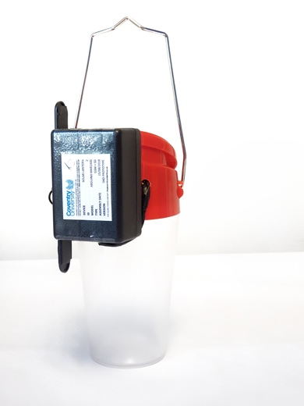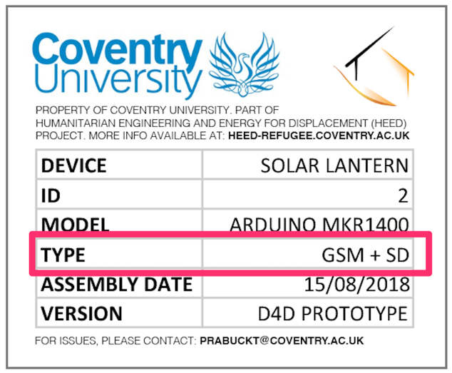**Solar Lantern demo (slide 20) (estimated time: 15 minutes):**

1. Show audience the lantern up close (GSM+SD version is the best to present). Look at “Type” on their labels to find the correct version (as seen on label above).
2. Explain briefly difference between 3 types of devices – GSM only, SD only, GSM+SD
   1. Mention that if GSM connectivity fails, we can still extract data locally from SD
   2. Or that we can use SD only version, that has longer battery life due to lack of GSM
3. Show audience the heed-data.coventry.ac.uk server (as seen on screenshots below):
   1. 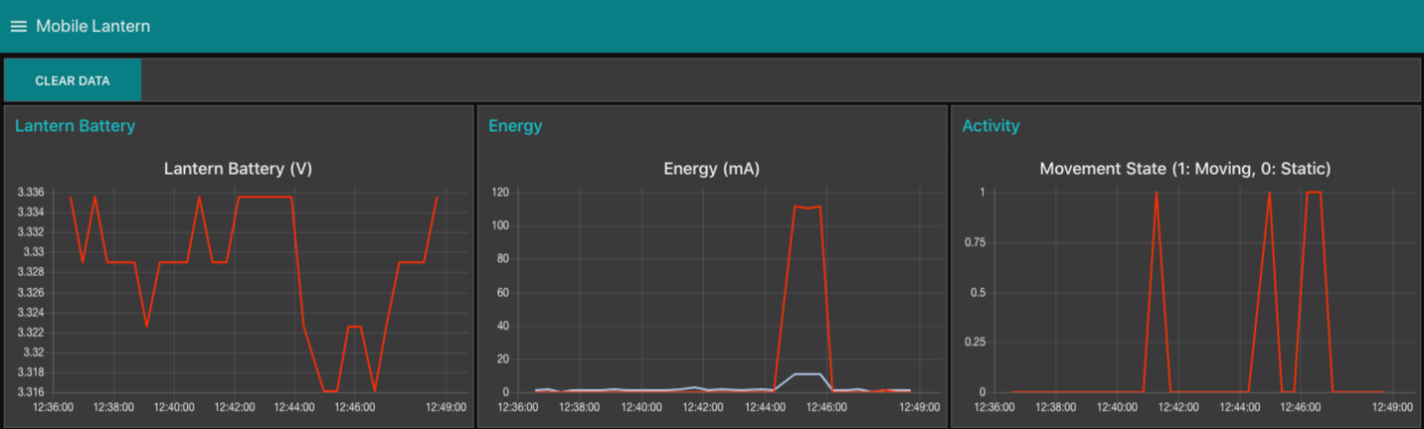Show all the charts and explain what each of them does  
      1. **Lantern battery** – shows voltage left on the li-ion battery
      2. **Energy** – Indicates whether lantern is turned on, and whether its charging
      3. **Movement** – determines whether the lantern is moved
   2. 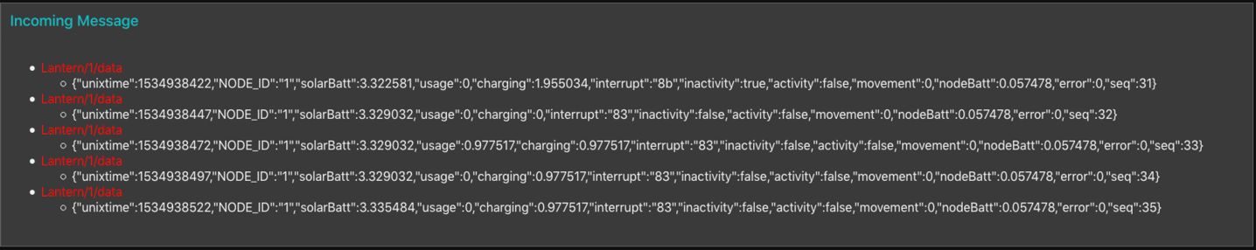Show incoming messages from the lantern:  
      1. Explain that this is what’s received from lantern by the server
      2. Data from those messages is plotted in the charts above
4. 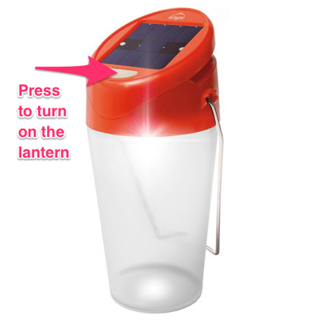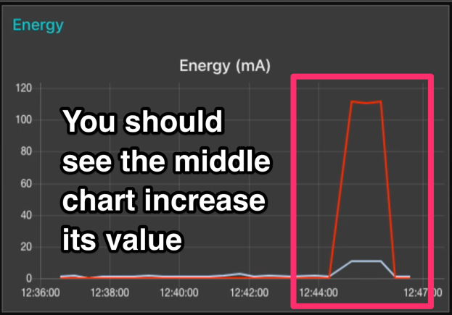Turn on the lantern light:  
   1. Wait till you see the red line on Energy chart (on picture above) increasing
   2. Explain how with it we can see when/how often/how long the lantern is turned on
   3. Turn off lantern and show the drop on the chart
5. 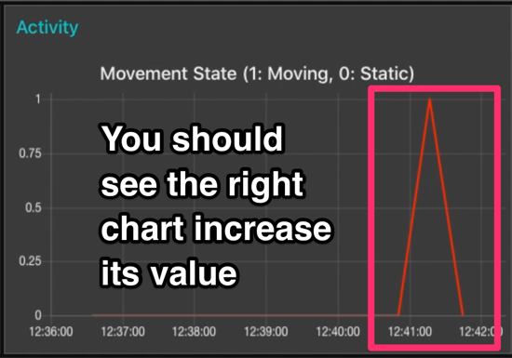Take couple steps with the lantern:  
   1. Wait till you see the Activity chart (on picture above) increasing
   2. Explain how with it we can monitor when/how often/long a person is walking with it
6. 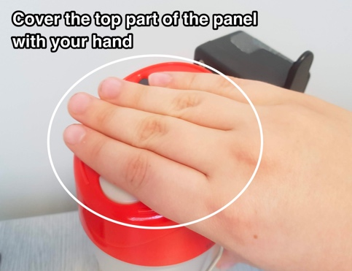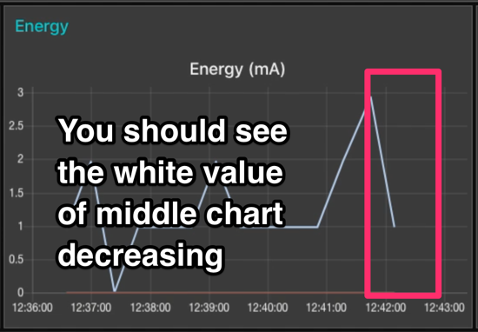Cover the lantern solar panel with your hand:
   1. Wait till you see the white line on Energy chart (on picture above) decrease
   2. Explain how with it we can monitor when and how much energy is generated from the panel to charge the lantern

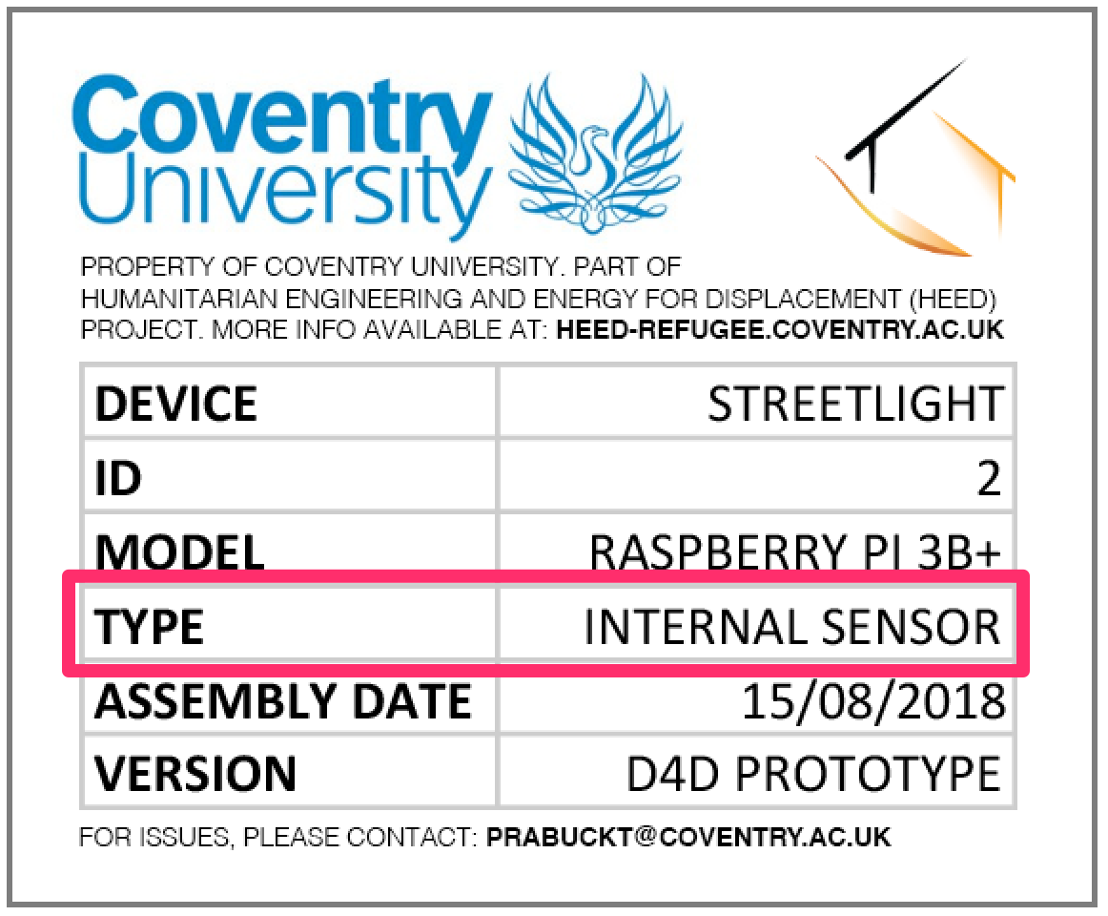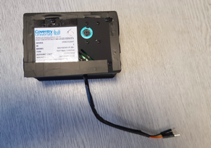**Streetlight demo (slide 37) (estimated time: 15 minutes):**

1. Show audience the Streetlight up close (The internal sensor one, that’s not connected). Look at “Type” on their labels to find the correct version (as seen on label above).
2. Show the difference between detachable HDMI sensor and internal sensor.
3. Move heed-data page to Streetlight tab:
   1. 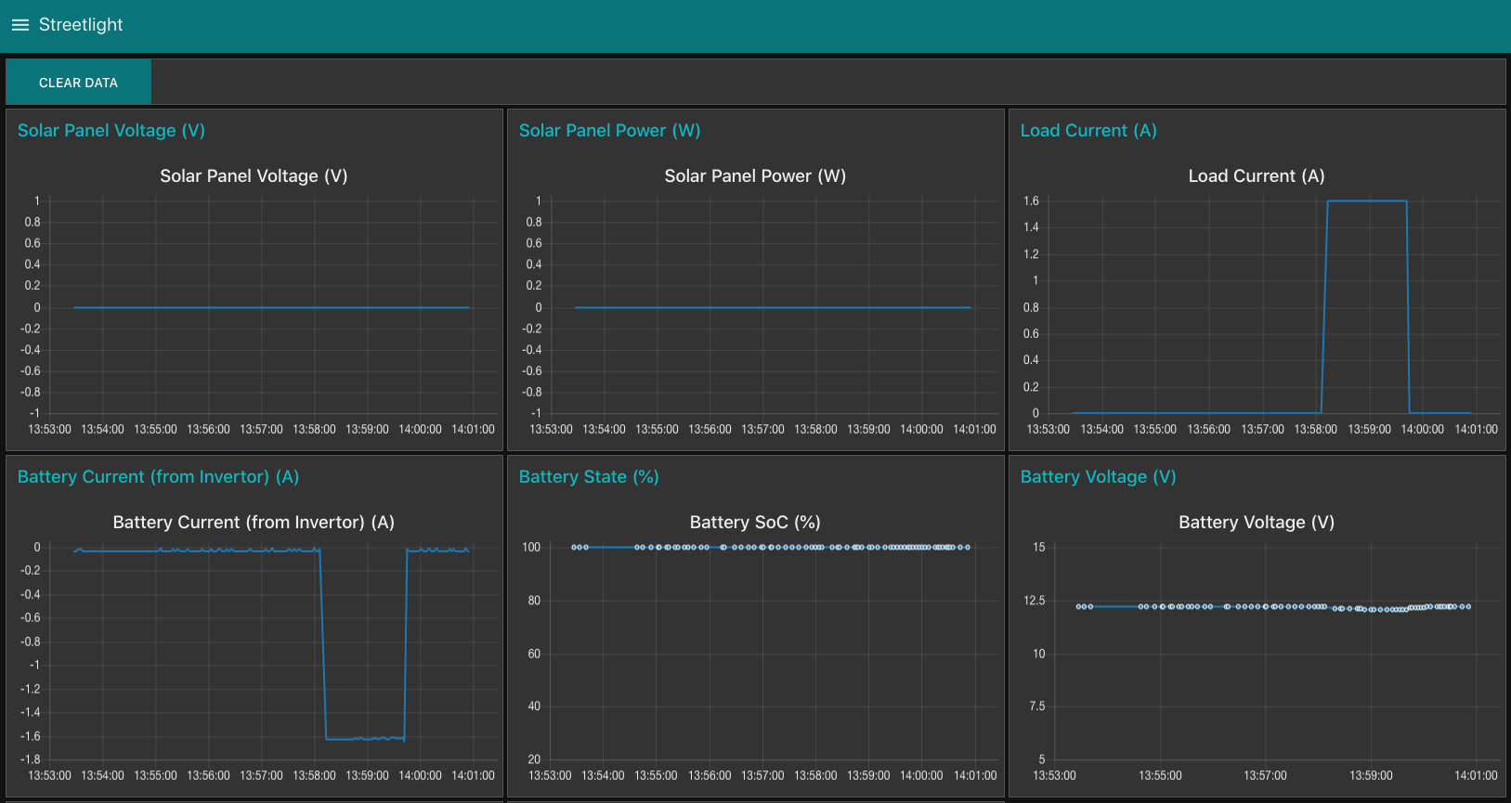Show all the charts and explain what each of them does  
      1. Solar Panel Voltage/Power – self-explanatory – values are flat, because the solar panel is not connected
      2. Load current – indicates how much power is used to power the light (drops when light is on)
      3. Battery current – self-explanatory (drops when light/phone charging is used)
      4. Battery SoC – battery state of charge – how much of battery charge is left
      5. Battery voltage – self explanatory
      6. Total footfall – total number of people walking under footfall sensor
   2. 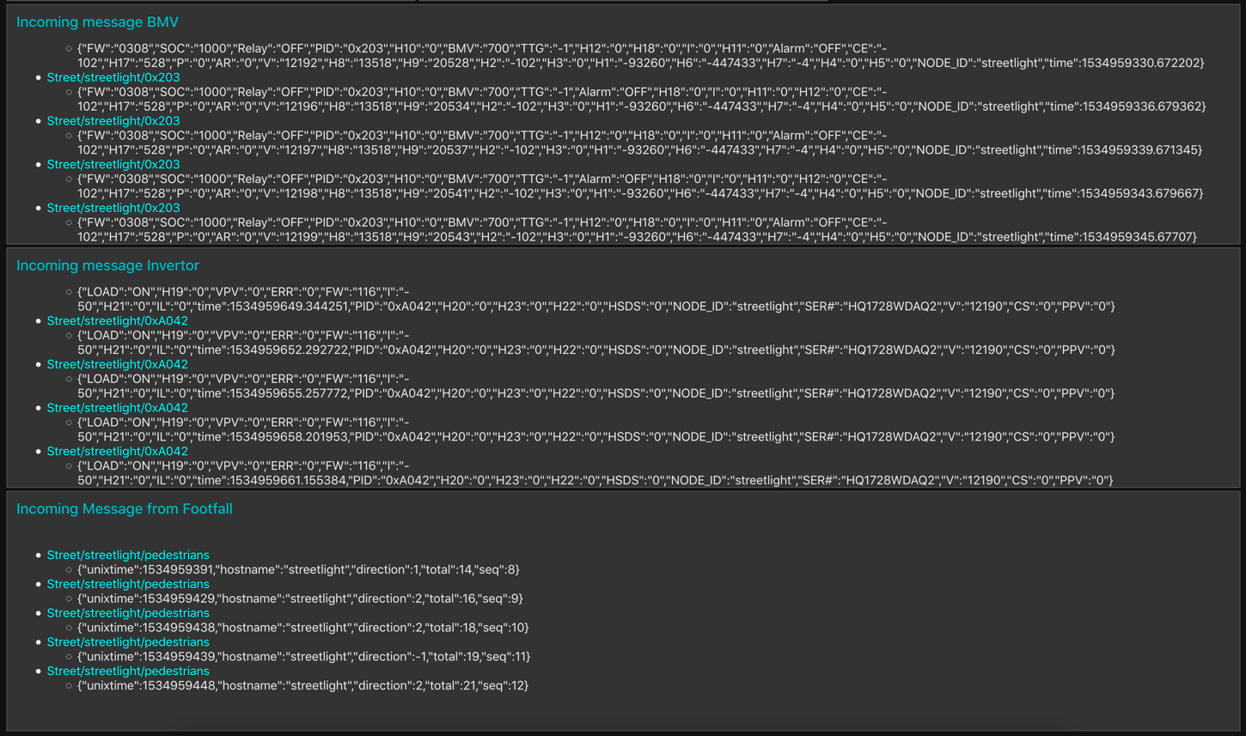Show incoming messages from Streetlight  
      1. Incoming message BMW – messages from battery monitor
      2. Incoming message Invertor – messages from charge controller
      3. Footfall – information coming from Footfall sensor
4. 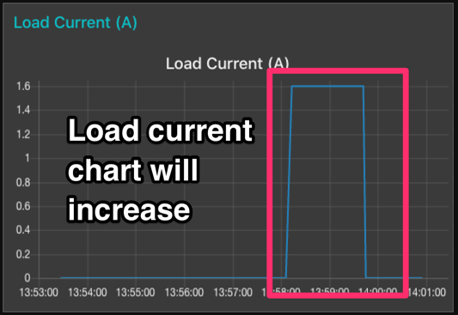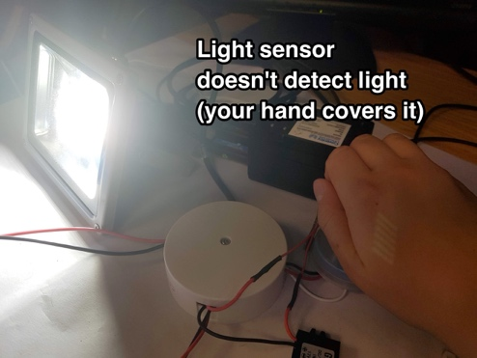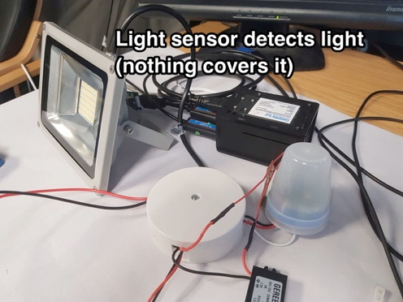Move the lamp away from audience (so it doesn’t flash them, and cover the light sensor, showing the light turning on when the surrounding gets dark)
5. 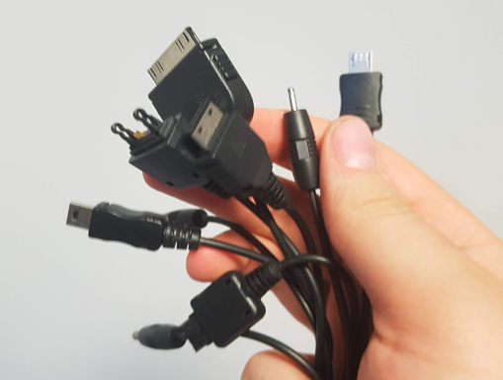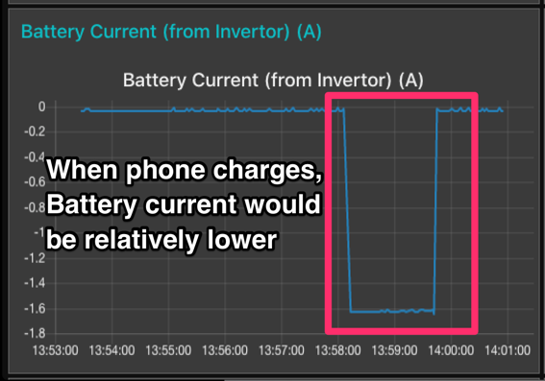Show how mobile phone can be charged using USB port of Streetlight:  
   1. Mention that we can turn on/off charging programmatically from Pi
6. 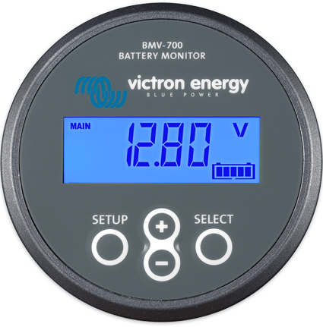Show the external battery monitor with voltage
7. Finally, show Footfall functionality:
   1. 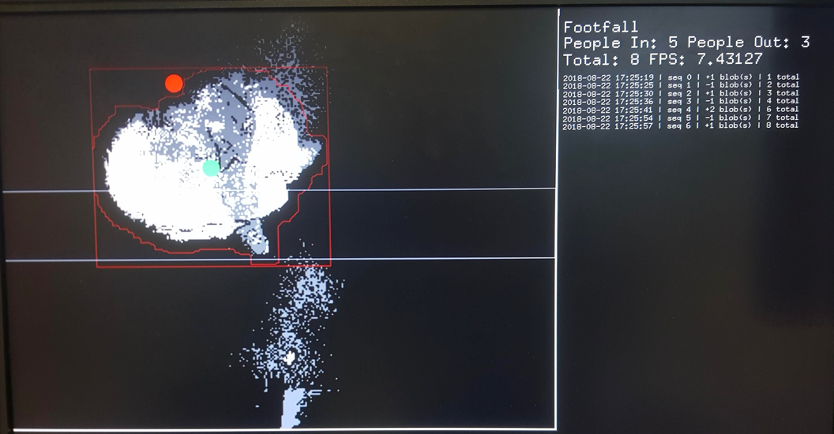Explain what we see on the display connected to device – what the Footfall sensor sees (blobs), and mention that the display is just for the demo purposes – the only thing we see on the server side are numbers visible on heed-data server.
   2. 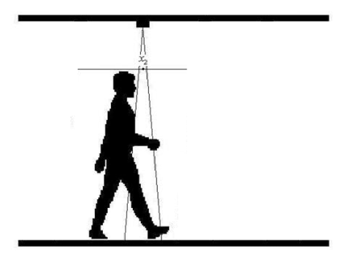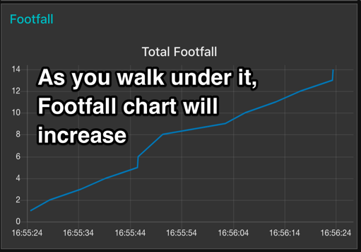Walk under the Footfall sensor couple of times, and show the incoming data on heed-server
   3. Mention that green LED lights up whenever sensor detects “a blob”
   4. 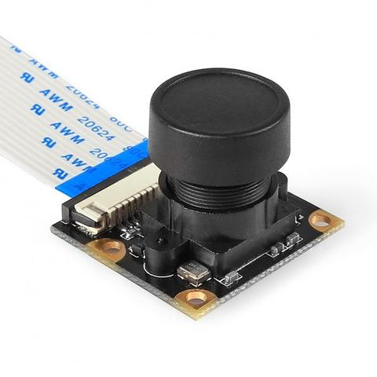Mention the lens that can increase the range if necessary

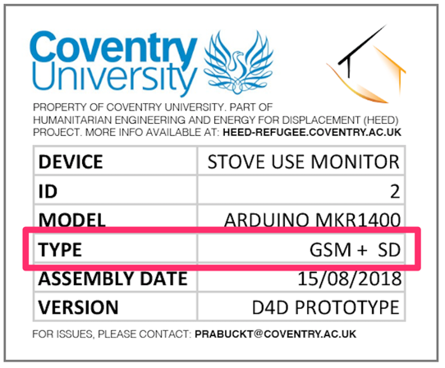**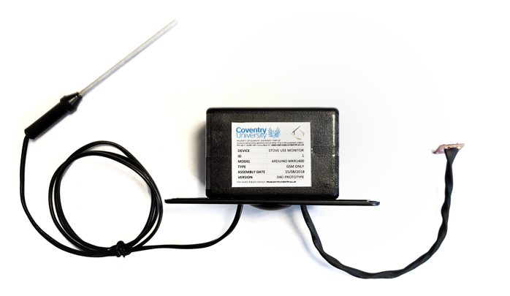SUM demo (slide 48) (estimated time: 10 minutes):**

1. Show audience the SUM up close (GSM+SD version is the best to present). Look at “Type” on their labels to find the correct version (as seen on label above).
2. Same as with Lantern, mention GSM+SD connectivity modes.
3. Move heed-data page to SUM tab:
   1. 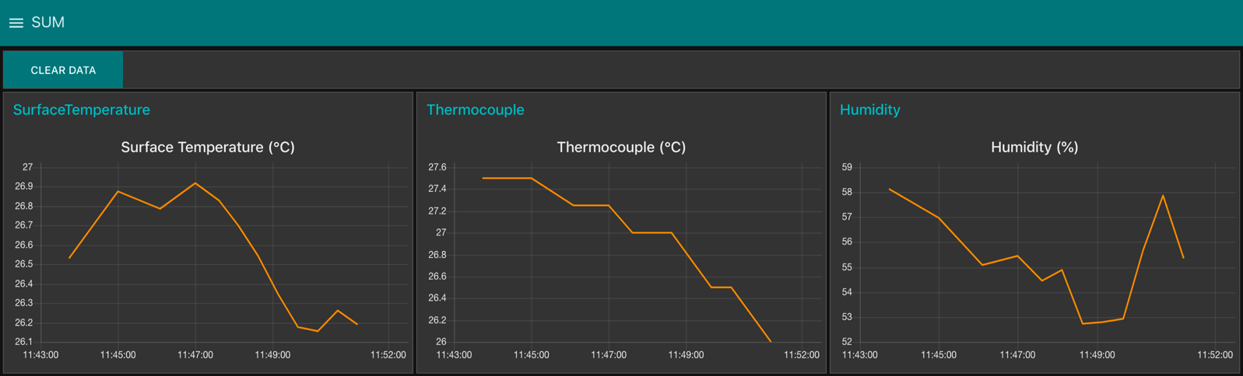Show all the charts and explain what each of them does  
      1. Surface Temperature – temperature taken from side of cook stove using Si7021 sensor
      2. Thermocouple – temperature inside the cook stove, from thermocouple
      3. Humidity – taken using Si7021 sensor
   2. 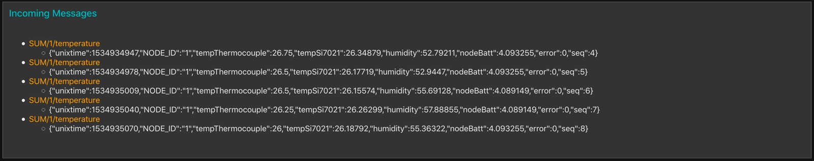Show incoming messages from SUM  
      1. Explain that this is what’s received from SUM by the server
      2. Data from those messages is plotted in the charts above
4. 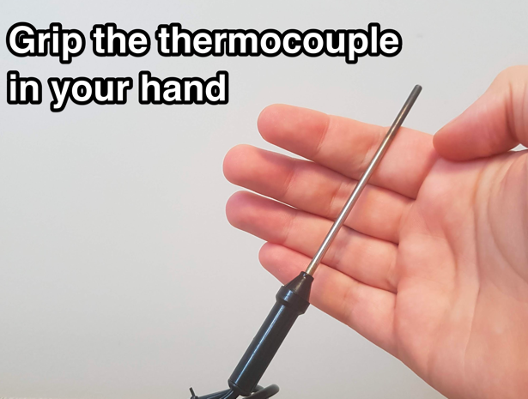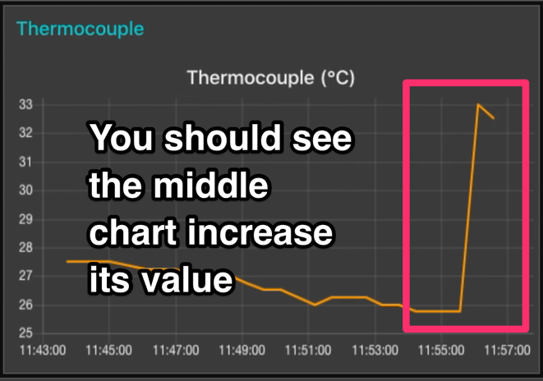Grip the thermocouple in your hands:  
     
   1. Wait till you see Thermocouple chart (on picture above) increasing
   2. Explain how with it we can see when and how often cook stove is used, and how it performs – how fast does it heat up
   3. Turn off lantern and show the drop on the chart

**Note:**

If any of the above fail, use the next slide in the presentation that  
contains a “backup” video recorded demo.

1. **Ideas to cover during workshops (2nd day)**
2. Let people “touch” the prototypes, unscrew them, show the insides, explaining where each part is and what it does.
3. Perform standard maintenance routine such as:
   1. Getting data off SD card with computer
   2. Changing the SIM card
   3. Changing the battery
   4. Reflashing the Arduino using computer and USB cable
4. Ask for feedback regarding build, functionality, ideas to focus on next
5. Detail upcoming work left to be done
6. Answer any other questions regarding the project
7. Let people move under the streetlight sensor on their own and see the data for themselves.  
   Same with the lantern and SUM.